Optimal Risky Portfolios
From Bodie, Kane and Marcus Chapter 7
Look at the Excel Spreadsheet: Two Risky Assets – No risk-free asset
Consider assets X and Y.
E(R_{X}) = 10% and σ_{X} = 7%
E(R_{Y}) = 20% and σ_{Y} = 10%

Let’s vary the weights (proportions of X and Y) of this portfolio, and observe what happens to E(R_{p}) and σ_{p} (expected return and standard deviation of the portfolio).

Case 1: Correlation (ρ_{X,Y}) = 1
E(R_{p}) = w_{X}(10%) + w_{Y}(20%)

σ²_{P} = w_{X}² (0.07)² + w_{Y}²(0.1)² + 2w_{X}w_{Y}(1)(0.07)(0.1)

Each value of w_{X} (and hence w_{Y}), gives us one point in the mean/variance space.

In each of these cases, we will not allow shorting of either X or Y, so the weights must each be between 0 and 1.

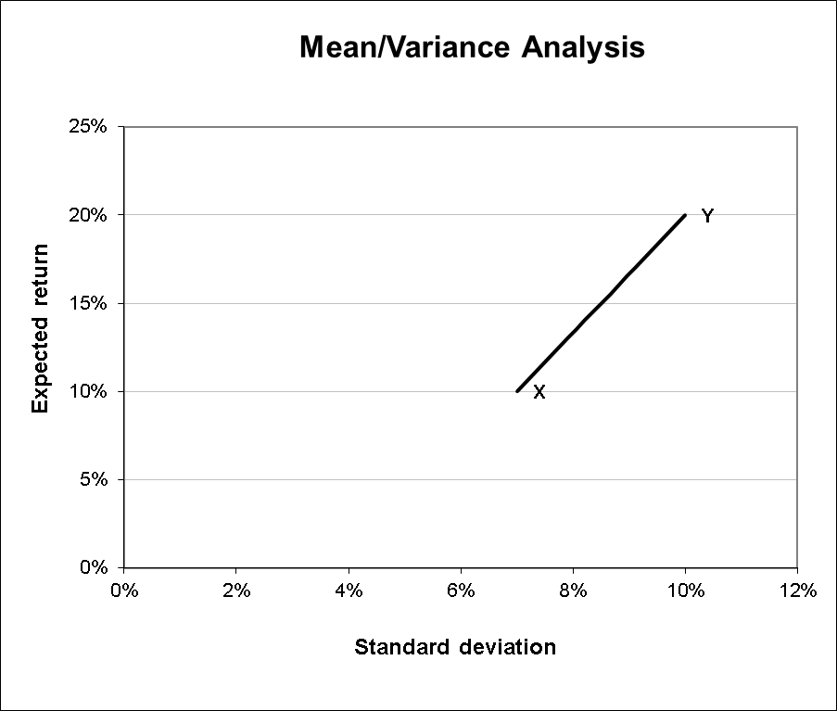

Case 2: Correlation (ρ_{X,Y}) = 0.5 (You can change the correlation in cell C7)
E(R_{p}) = w_{X}(10%) + w_{Y}(20%)

σ²_{P} = w_{X}² (0.07)² + w_{Y}²(0.1)² + 2w_{X}w_{Y}(0.5)(0.07)(0.1)

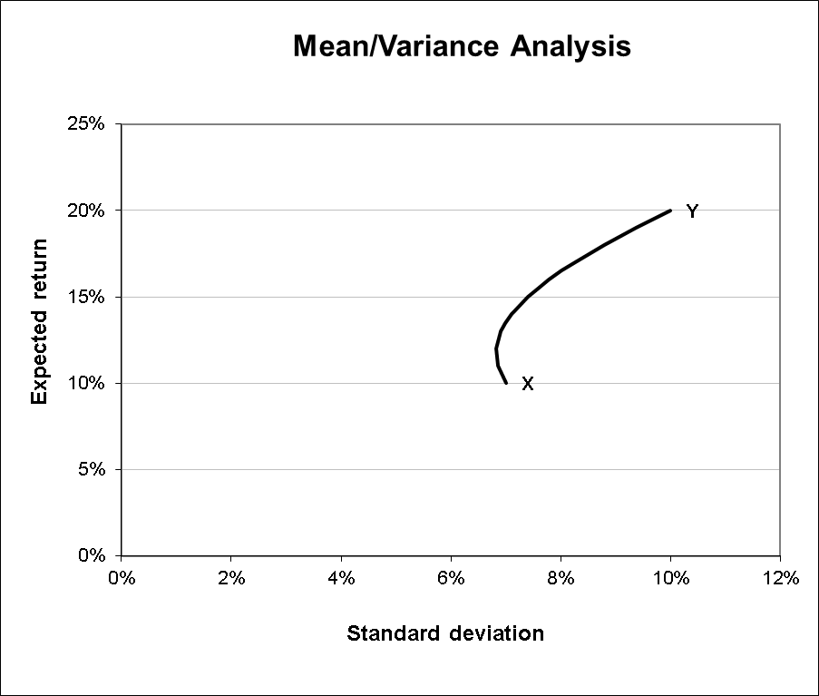
Case 3: Correlation (ρ_{X,Y}) = 0.0

E(R_{p}) = w_{X}(10%) + w_{Y}(20%)

σ²_{P} = w_{X}² (0.07)² + w_{Y}²(0.1)² + 2w_{X}w_{Y}(0)(0.07)(0.1)

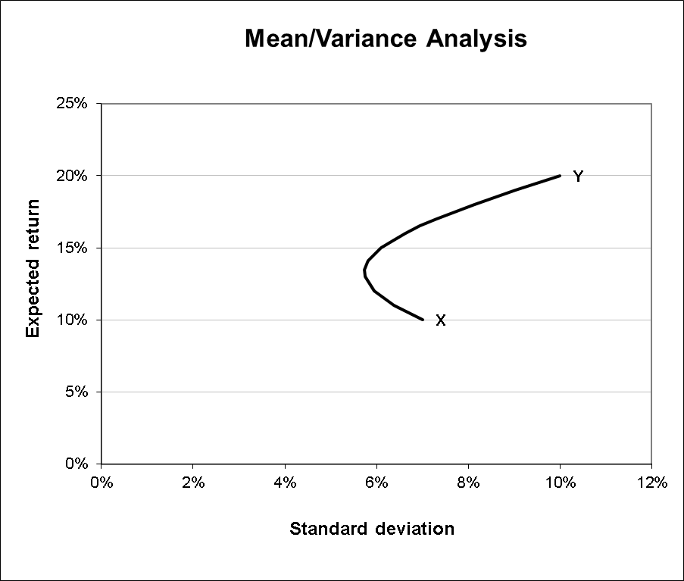
Case 4: Correlation (ρ_{X,Y}) = -0.5

E(R_{p}) = w_{X}(10%) + w_{Y}(20%)

σ²_{P} = w_{X}² (0.07)² + w_{Y}²(0.1)² + 2w_{X}w_{Y}(-.5)(0.07)(0.1)

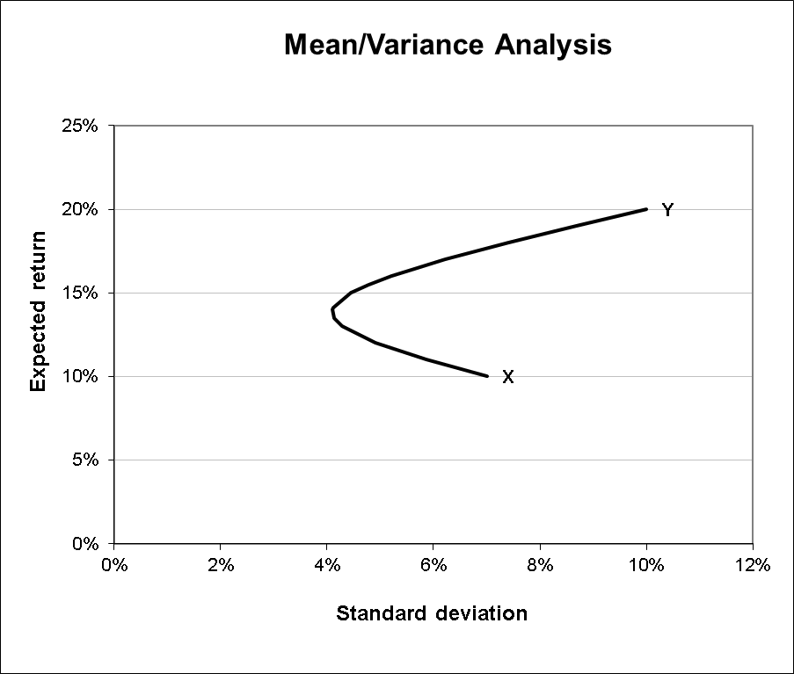

Case 5: Correlation (ρ_{X,Y}) = -1.0

E(R_{p}) = w_{X}(10%) + w_{Y}(20%)

σ²_{P} = w_{X}² (0.07)² + w_{Y}²(0.1)² + 2w_{X}w_{Y}(-1)(0.07)(0.1)

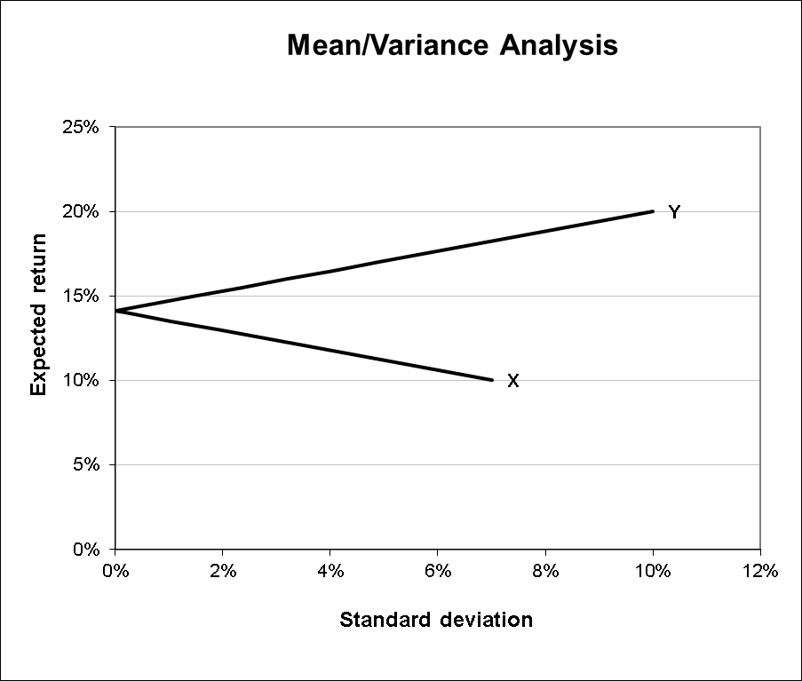
Points to be noted from this exercise:
When the correlation is +1.0 (case 1), the opportunity set is simply a straight line. We can see this as follows:
σ²_{p} = w_{X}² σ²_{X} + w_{Y}²σ²_{Y} + 2w_{X}w_{Y}(1)(σ_{X})(σ_{Y})
= (w_{X} σ_{X})² + (w_{Y} σ_{Y})² + 2(w_{X} σ_{X})(w_{Y} σ_{Y})
= (w_{X} σ_{X} + w_{Y} σ_{Y}) (w_{X} σ_{X} + w_{Y} σ_{Y}) by the “FOIL” formula
= (w_{X} σ_{X} + w_{Y} σ_{Y})²
⇒ σ_{p} = (w_{X} σ_{X} + w_{Y} σ_{Y})
which is a linear combination of the standard deviations of the two assets.

If we have a correlation of –1.0 (case 5), the opportunity set is two straight lines meeting on the Y-axis (expected return axis).
σ²_{p} = w_{X}² σ²_{X} + w_{Y}²σ²_{Y} + 2w_{X}w_{Y}(-1)(σ_{X})(σ_{Y})
= (w_{X} σ_{X})² + (w_{Y} σ_{Y})² - 2(w_{X} σ_{X})(w_{Y} σ_{Y})
= (w_{X} σ_{X} - w_{Y} σ_{Y}) (w_{X} σ_{X} - w_{Y} σ_{Y}) by the “FOIL” formula
= (w_{X} σ_{X} - w_{Y} σ_{Y})²
⇒ σ_{p} = (w_{X} σ_{X} - w_{Y} σ_{Y}) – so this is our first straight line.

But we also have:
σ²_{p} = w_{X}² σ²_{X} + w_{Y}²σ²_{Y} + 2w_{X}w_{Y}(-1)(σ_{X})(σ_{Y})
= (w_{X} σ_{X})² + (w_{Y} σ_{Y})² - 2(w_{X} σ_{X})(w_{Y} σ_{Y})
= (w_{Y} σ_{Y} – w_{X} σ_{X}) (w_{Y} σ_{Y} – w_{X} σ_{X}) by the “FOIL” formula
= (w_{Y} σ_{Y} – w_{X} σ_{X})²
⇒ σ_{p} = (w_{Y} σ_{Y} – w_{X} σ_{X}) – which is our second straight line.

For correlations other than –1.0 and +1.0, the portfolio standard deviation is not a linear function of the standard deviations of the two assets, and we don’t have straight lines, but a hyperbola.

As we keep decreasing the correlation from +1.0 toward –1.0, the hyperbola curves further towards the left (the end-points are still fixed).

This is because, as we decrease the correlation, we have diversification. i.e. we have some combinations of these two assets which have lower standard deviations than either of the two assets by themselves, for each given expected return.

As we change the correlations, the standard deviation is the only thing that changes.
The portfolio expected return does not change.

Why? Because it is E(R_{p}) = w_{X} E(R_{X}) + w_{Y} E(R_{Y}), which does not depend upon the correlation at all.

We can find the Minimum Variance Portfolio (MVP) for any given correlation by using Solver to find the smallest standard deviation by changing the weight on X.

Note that with sufficiently low correlations, it is possible that portfolios formed from our two assets have a lower variance (and standard deviation) than either asset by itself.

There are an infinite number of portfolios that can be formed from these two assets. Varying the weights on the two assets (while making sure the sum of both the weights is 1), gives us the full investment opportunity set with 2 risky assets.

Two Risky Assets; One risk-free asset
Now, let’s add the risk-free asset with R_{f} = 5% into the mix. Also, let’s fix the correlation between the returns of assets X and Y at ρ = 0.10. You can see this in the spreadsheet: The MVE Portfolio with 2 Risky Assets. The following diagram plots two possible Capital Allocation Lines.

Let’s start with CAL_{Y}. We can see that by adding the risk-free asset to Asset Y, we can do better than by doing the same with Asset X.

For every level of standard deviation (risk) on CAL_{X}, there is a corresponding point on CAL_{Y} (vertically above it) that has a higher expected return. For example, at a standard deviation level of 4%, one could be at portfolio A on CAL_{X} with an expected return of close to 8%; however, at the same level of risk, one could be at portfolio B on CAL_{Y} with an expected return of 11%.
Obviously, a risk-averse investor would prefer to be at B on CAL_{Y}.
Since the same logic holds for every point of CAL_{X} and the corresponding point on CAL_{Y}, we say that CAL_{Y} dominates CAL_{X} from a mean-variance standpoint.
It is clear that pairing the risk-free asset with Asset Y is much better than pairing it with Asset X. But, what if we are willing to consider all possible portfolios of X and Y (not just X or Y) to pair with the risk-free asset? Which would be the optimal risky portfolio?

To find out, imagine starting with CAL_{X} and pivoting it counter-clockwise about the risk-free asset. Soon you will come to CAL_{Y}. If you continue further, is there a CAL that dominates CAL Y also? Yes. How far can you go? Until the CAL is tangent to the investment opportunity set.
Why can’t you pivot further than the tangent line? Because, at that point, you will have bypassed the entire investment opportunity set of risky assets. After all, we need to pair the risk-free asset with some feasible portfolio! Beyond the tangent, there are no more feasible portfolios to pair with the risk-free asset.
The particular portfolio of X and Y at the point of tangency is called the tangency portfolio. In combination with the risk-free asset, it provides the CAL with the highest slope i.e. it provides the maximum reward-to-risk ratio, or Sharpe ratio. It is also called the Mean Variance Efficient (MVE) portfolio. It is the optimal risky portfolio when you have a risk-free asset.

The Sharpe ratio is the ratio of portfolio expected return (above R_{f}) to portfolio standard deviation. Every point on the graph has a Sharpe ratio. To find the MVE portfolio, we want to find the highest possible Sharpe ratio. We can do this fairly easily with Solver.
Three Risky Assets: An Illustrative example
It is instructive to look at an example with 3 risky assets. The intuition from this example can be easily generalized to N risky assets.
Let’s add one more risky assets to our existing risky assets, and let’s call it Z. We have to specify the expected return and variance of Z. Also, we need to specify the correlation (or equivalently the covariance) between Z and X and between Z and Y.
It is useful to organize this information into vectors and matrices, as it can get out of hand pretty quickly as the number of assets increases.
We write the mean return vector as: , and the matrix of variances and covariances as:

Notice that asset Z has an expected return of 15%, a standard deviation of 12%, a correlation of 0 with Asset X, and a correlation of 0.9 with Asset Y.
When you have three assets X, Y and Z, the investment opportunity set becomes all portfolios that can be formed from the three assets, i.e., an area rather than a straight line in mean/variance space.
Out of the infinite number of portfolios that we can form with the three assets, we have to find the portfolio that results in the least possible risk for each given level of expected return. Alternatively, there is one portfolio that results in the maximum expected return for each level of risk.

Again, Solver will help us find the solution. We will need to run Sover for every level of Expected Return for which we want to find the minimum possible standard deviation. Once we map out all these points, we’ll find that we have a hyperbola.
This hyperbola is called the efficient frontier (though technically, only the top portion of it is efficient). Thus, the efficient frontier plots all optimal combinations of risk and return in the presence of n risky assets. Let’s look at the efficient frontier for our three assets.
In the above diagram, we can see the efficient frontier with respect to our three assets. This frontier is the envelope of all risk-return combinations of the three assets. It contains the efficient frontiers formed by pair-wise combinations of the three assets (and more!).
On this frontier, the little black square is the Minimum Variance Portfolio (MVP). This portfolio has the minimum variance of all possible portfolios formed from X,Y, and Z. Again, we can find its location with Solver.
The MVP has an expected return of 12.57% and a portfolio standard deviation of 5.98%.
The part of the frontier that lies on the hyperbola and above the MVP is the true efficient frontier. It is the set of portfolios that a risk-averse investor might choose. It consists of any portfolio that is not dominated by another portfolio (no portfolios directly north, directly west, or northwest).
Thus, of the initial feasible area, we are left only with the northwest edge of he hyperbola as points that our risk-averse investors might choose. In general, as we keep adding more and more assets, the efficient frontier will expand and move west.

One important result of all this is called Two-Fund Separation. Two-Fund Separation says that all portfolios on the mean-variance efficient frontier can be formed as a weighted average of any two portfolios on the efficient frontier.

The Limits of Diversification
So far, we have seen that by adding more and more assets, we can get more and more diversification and reduce portfolio variance and standard deviation.
Can we ever eliminate all portfolio variance? In other words, can we reduce the portfolio variance to zero?
Let us start from our general formula for portfolio variance (weighted var/cov matrix):

Since we are considering a portfolio of many assets, assume , assume , and . Note that we have N variance terms and N²-N covariance terms. Note that N²-N can also be written as N(N-1).

This results in:
=
As N → ∞, → 0 and → 1

Conclusion 1: For a well-diversified portfolio, the variance of the portfolio will be close to the average covariance between the assets.

Conclusion 2: If the average covariance (equivalently, correlation) is not close to zero, we can never eliminate all risk. Even after diversifying as much as possible, we are still left with some residual risk.

The risk that we can get rid of just by diversifying is called unique (or unsystematic or idiosyncratic or diversifiable) risk.
e.g.: A fire at IBM’s headquarters affects IBM stock, but this risk is unique to IBM stock. It can be gotten rid of by diversification.
The risk that remains even after diversifying is called market (or systematic or undiversifiable) risk.
e.g.: A change in interest rates affects the entire economy (though it may not affect each stock in the same way). This risk cannot be gotten rid of by diversification.

This can be seen (and experienced) through the spreadsheet “Am I Diversified?”. Here, you can pick any 30 stocks and a macro in the spreadsheet will go to Yahoo! Finance and find the adjusted closing monthly prices for each stock and the S&P 500 for the past 60 months. The spreadsheet uses that data to calculate the (monthly) standard deviation of 30 different equally-weighted portfolios and graph them along with the standard deviation of the S&P 500. Though the stocks you select may not cause your graph to look exactly like figures 7.1 and 7.2 in your text, you will see how the addition of randomly selected stocks can eliminate unique risk, but not market risk.

Three or More Risky Assets and a Risk-free Asset
Now that we have the efficient frontier with three or more risky assets, we can throw our risk-free asset into the mix, and find the optimal Capital Allocation Line.

You can see a combination of 5 risky assets with a risk-free asset in the spreadsheet “Several Assets Dynamic Model”. This model allows you to change the expected returns, standard deviations and correlations between the assets by clicking on their spinners.

The risk-free asset is noteworthy as it changes the shape of the efficient frontier from a curve (the northwest part of the hyperbola) to a straight line (the CAL_{MVE}).

This is a good time to look at how we might do this with some real-world data. Look at the “Efficient Frontier for Eight Securities” spreadsheet. Here you will find monthly returns for eight different stocks and the S&P 500 (our proxy for the market). We use this information to calculate expected returns, standard deviations, and correlations. From there, we can use Solver to calculate the minimum standard deviation portfolio for any feasible expected return. By connecting the points, we can graph the efficient frontier for these risky assets. Further, if we add a risk-free asset into the mix, we can determine the MVE portfolio. Finally, we can determine where a particular investor will choose to be on the CAL_{MVE} by using solver to maximize her utility by changing the weights on the MVE and R_{f}.

